Jerry Olds

1001533643

IE-4378-001

11/25/2019

**Final Report**

Competition: Intelligent Ground Vehicle Competition

Mission: The vehicle shall navigate an unknown obstacle course from start to finish while staying inside the boundaries of the course and avoiding all obstacles.

Requirements

1.0 The system shall take no human input (other than e-stop) while in autonomous mode  
2.0 The system shall have e-stop functionality  
 2.1 The system shall come to a complete stop if the wireless e-stop button is pressed  
 2.2 The system shall come to a complete stop if the mechanical e-stop button is pressed  
3.0 The system will be propelled by wheels  
4.0 The system shall meet dimension requirements  
 4.1 The system will be at least 3 feet long and at most 7 feet long  
 4.2 The system will be at least 2 feet wide and at most 4 feet long  
 4.3 The system shall not exceed a height of 6 feet  
5.0 Vehicle power must be generated on board  
6.0 The system shall meet speed requirements  
 6.1 The system shall have an average speed of 1 mph upon completion of the course  
 6.2 The system shall not exceed a speed of 5 mph  
7.0 The system shall meet safety light requirements  
 7.1 The system’s safety light shall display a solid green light when powered on  
 7.2 The system’s safety light shall display a blinking green light when in autonomous mode  
8.0 The system shall carry a 20 pound, 18” x 8” x 8” payload while in operation  
9.0 The system shall meet environmental requirements  
 9.1 The system shall be able to operate in a grassy area  
 9.2 The system shall be able to use ramps (natural or artificial) with gradients not exceeding 15%  
 9.3 The system shall be able to operate in light rain or drizzle  
10.0 The system shall be started by a one touch motion (pressing a button, left mouse click,   
 pressing the enter key on a keyboard, flipping a switch, lifting e-stop, etc.)

Component Mapping

Human-Robot Interaction

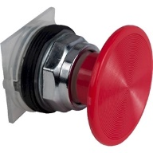

Power

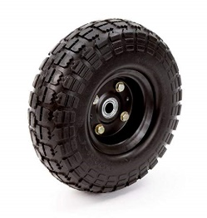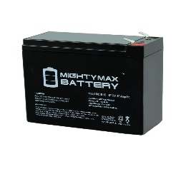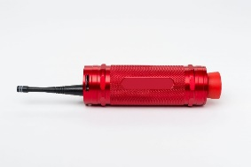

Wheels

Mobility

12 Volt Mighty Max Battery (x2)

Laptop

Wireless E-Stop Button

Mechanical E-Stop Button

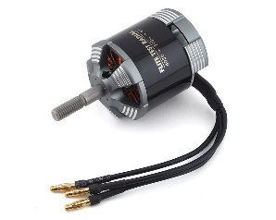

Communications

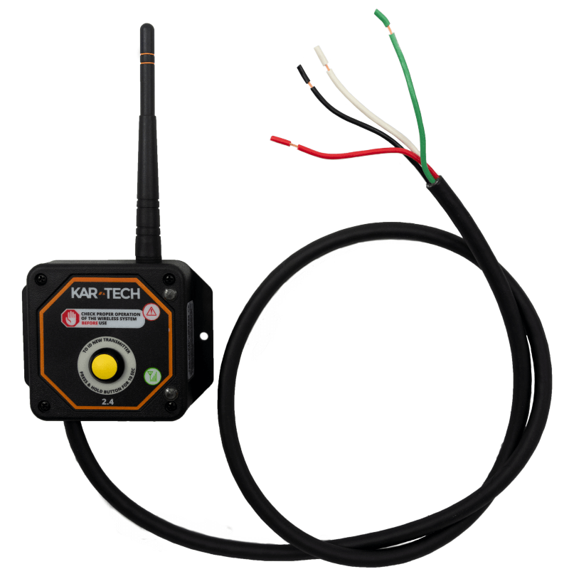

Brushless Motors (x2)

Wireless E-Stop Antenna

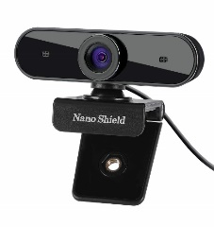

# N910 Skype Web Camera Wide Angle



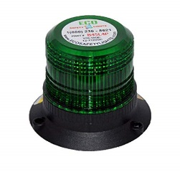

Sensors

# Safety Light

Subsystems

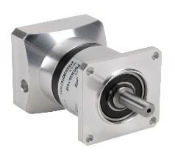

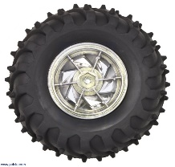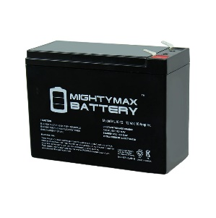

Wheels

Motors

Batteries

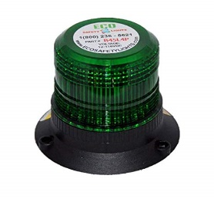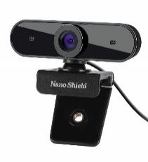

Sensors

Camera

Laptop

Safety Light

Wireless E-stop Antenna

Systems Needed to Support Guidance, Navigation and Control

Navigation



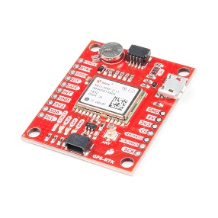

Systems in the Navigation block retrieve the vehicle’s position and identify the course boundaries and obstacles. The Guidance block then calculates a path based on the input received from the Navigation block. The control block then moves the system following the path generated in the Guidance block.

Brushless Motors (x2)

Wheels

Control

Guidance

Laptop

Robot Operating System

Sparkfun RTK GPS

Lidar Sensors

# N910 Skype Web Camera Wide Angle

Sensors / Sensor Fusion Needed for Competition

# Sensors

Sensor Fusion:

N910 Skype Web Camera + Lidar Sensor for obstacle detection.

N910 Skype Web Camera + Sparkfun RTK GPS for mapping and localization



# Sparkfun RTK GPS for position and orientation

# N910 Skype Web Camera Wide Angle for obstacle detection, lane detection, and mapping.

# Lidar Sensor for obstacle detection and distance of obstacle from vehicle.

# N910 Skype Web Camera Wide Angle



# Lidar Sensor



# Sparkfun RTK GPS

Path Planning Needed for Competition

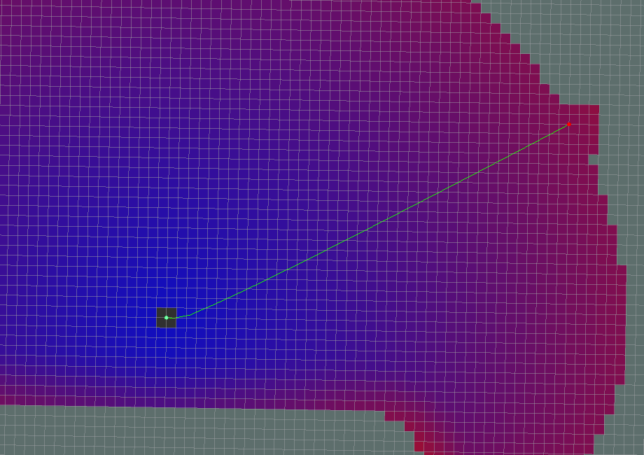ROS package Global Planner used for path planning of the vehicle. A* Path method used due to it being faster and more efficient than Dijkstra’s algorithm. A* Path method is unpredictable in its path generation and will most likely generate a different path every time.

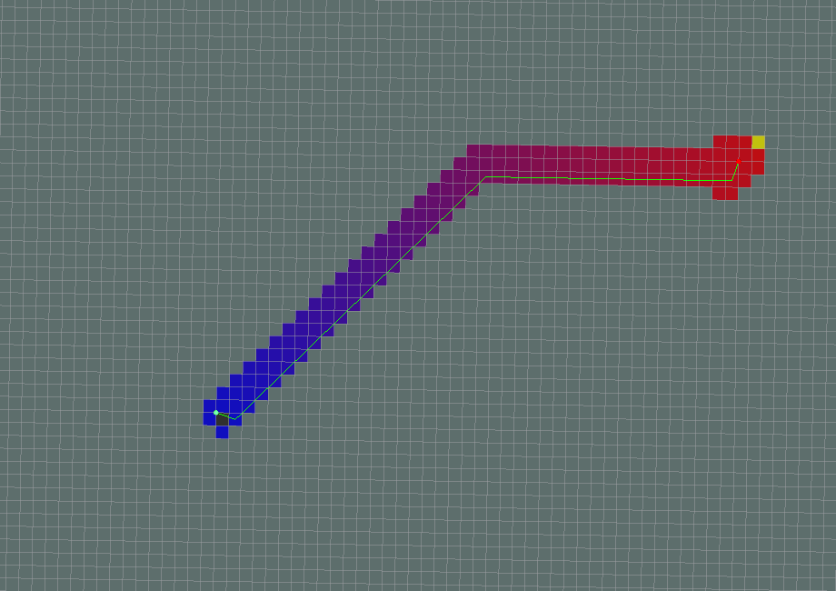

Dijkstra’s

A*

Localization and Mapping Needed for Competition

ROS package gmapping used for Simultaneous Localization and Mapping (SLAM). Gmapping is laser based and relies on the vehicle’s Lidar sensor to generate a 2-D occupancy grid map.

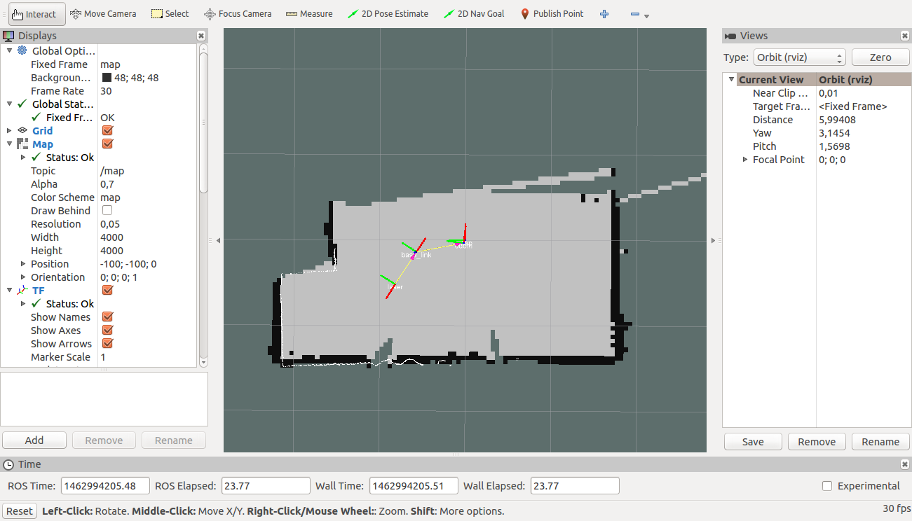

Communications Needed for Competition



ROS navigation stack takes readings from Lidar, GPS, and camera and based on those readings creates safe velocity outputs for the system. Implements partially autonomous communication form.

Wireless E-Stop Antenna



Wireless E-Stop Antenna used for picking up signal from Wireless E-Stop button to stop vehicle wirelessly.

# N910 Skype Web Camera Wide Angle



# Safety Light

Safety Light used to indicate the state of the vehicle.



Sensors

Autonomy and Human/Operator Interface Needed for Competition

Autonomy

The system will use a reflexive control scheme due to its fast reaction speeds and the environment in which it will be operating in is unknown. The system will use A* algorithm that will be constantly updating the path it will be following as data is collected from the camera and Lidar.

Human/Operator Interface

Once the vehicle begins traversing the obstacle course, it can accept no human input other than the wireless or mechanical e-stop button. A simple GUI will be created that will begin autonomous traversal of the obstacle course on input from the operator.